Flappa & Smooth Intake

This is stuff I have cut and pasted off the forum so it is a bit disjointed. Ive added my bits throughout.

I have done this myself and it works well and is easy.

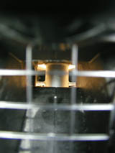

more air, more fuel, more power
1. i totally gutted the intake,
2. got rid of the rain catcher steps you can see when you look into your intake,
3. I modified the intake so it doesn’t use the resonance noise chamber,
4. matched the frame to the intake duct to help airflow transition,
5. the surface of the duct is now perfectly smooth on purpose so as to create a boundary layer with the airflow.
6. Make sure you put the sensor (black thin thing) back into the intake.
the idea is to get as much non-turbulent air as possible to the Evo high flow airfilter, that combined with the Evo style home made airbox gives a lot more mid and top end power. Especially combined with new BEF end cans or your own Cored cans. After getting a dyno done and the air/fuel analyised you will see if a PC3-usb is really needed to adjust the air fuel. But don’t just buy a PC3 as you may not need it.

It all starts at the intake
if you take the intake duct completely off the bike and disassemble it you will see where the restrictions are
you may not think they are restrictions until you see something like the HRC RC51 carbon intake, then you will see how much better it 'could' be
basically i ported the crap out of it, i used a dremal to remove the steps. But my mate used his electric drill. – The steps are only there to catch rain according to aprilia – Also remove the middle runner which houses the flapper, and i blocked up the resonance chamber. But I just used Duct Tape to block off the holes. Even 15000km later it is holding fine.
i had thought about adding the resonance chamber to the volume of the intake but i left it for now
i also removed a small chamber that hangs off the bottom of the duct which is connected to the flapper system, it is like a small equalizing chamber and now you dont need it
In the photos there was a small plastic plate made that went over the flapper activator thingy and sealed it, but as mentioned, using perminant Duct Tape works perfectly.
it is one of those things where once you have it apart you will see why it is all there in the first place and then how to make it better
And if you ruin the whole intake that’s ok, cos they are very cheap!
Q. Coming from a part of the world where rain is a regular occurrence, should leave as it is?
A. my own opinion is that because the water has to go 'up' through the filter it wont be a problem
i know why aprilia put the water steps there but i think for all intense purposes it is an overkill. Especially as most water entering the intake will be with the bike travelling at speed so it is likely that it would have been carried in past the tiny steps anyway.
and if water does get past the filter then that is called water injection baby it will make the air more dense and produce more power
the steps create turbulence, some will agree that turbulence in the duct is a good thing, i don’t and neither does Clarkie. Besides, it all slows as it hits the filter anyway.
if i was not going to run a filter on my race bike that would be a different story, but that is not really relevant for 99% of 04 owners
A hacksaw blade is all you need to cut out the "rain steps". A dremel took care of the rest of the cutting and cleaning up.
In the attached photos you will see a plate made of metal. Don’t bother…just use tape ☺

Seriously, I just used Duct Tape to seal all the holes and it has worked perfectly for over 1 year and 25000km
Here's some Pic's
HARDCHARGER has attached this image:
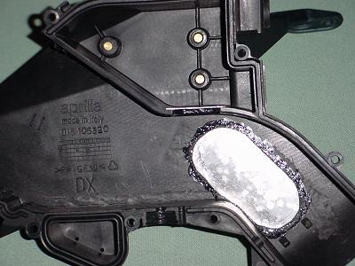

Heres a pic of the inside before the cleaning for those who have never seen it before.
mille-ryan has attached this image:
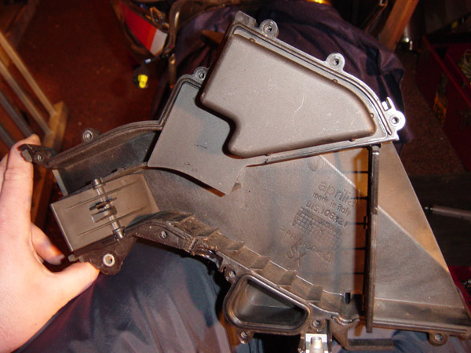

This is an ‘after’ pic
HARDCHARGER has attached this image:
