04 RSVC Exhaust Conversion.
Read everything from start to finish first, as many questions will be answered later in the text.
Ive also made some changes over time and they may not be mentioned until later.
Two revisions that I recommend are an Alloy core instead of a steel one, as Alloy will give a deeper sound.

I put a straight through core of 65mm, but I believe you will get more power if you have the core a tapered/cone shape, with the entry end being about 65-70mm, and the exit end (at the end cap) to be about 50-55mm.

Using the tapered core does give more top end AND mid range based on the length of these stock cans.
But, tapered cores are bloody hard to find….

HOWEVER… you can have one easily made. All you need is a thin (1.5-2mm) piece of perforated alloy sheet. Building and engineering places can probably help. Then just have the sheet rolled into a conical shape and spot welded. It is a lot easier than it sounds. I used some galvanised perforated sheet for some last week. It had much larger holes in it too. Sounded good.

Stainless cores give a harsher less deep sound. Alloy or normal steel is better.

The harder bit is cutting the end cap to have a 50mm exit. If you just fully remove the interior of the end cap (pics farther into the doc) it will result in a 65mm exit on the end cap. So either cut the exit smaller, or there are 2 other options
1. right at the end of the core where it is 50mm, thae it splayed out (spread out) to 65mm again. Do this in the last inch of the core.
2. Add a flat plate to the inside of the end cap and have a 50mm hole cut in it. Spray paint it black to blend it in.

Cheers
Also, as you want the absolute max performance. I suggest removing the joining pipes for the headers. This does not require removal of the headers, but you may need to loosen the front header nuts to be able to drop the joining ‘spaghetti’ pipe out. Then get a Dremil with an extension arm and grind down the bug overlaps in the inside of the pipes where the front and rear pipes join.
These pics are looking down the pipe from the front end. The dark semi circle is where the rear pipe intrudes into the front pipe. It restricts flow and there are major overlaps at the front of it as well that intrude at least 5-10mm into the pipe. This restricts flow. Sorry that the pics are not very clear due to shadows etc. But when you remove you joining/spaghetti pipe and look down it you will see what I mean. In fact, when you remove the right muffler and look down the pipe (The pipe that remains on the bike ) you will see the intrusion of the left pipe into the right.
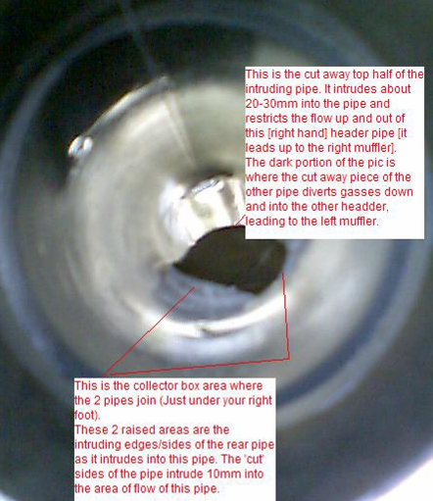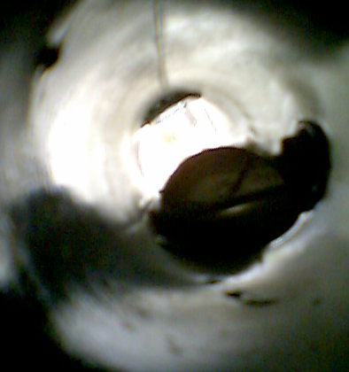
Exhaust Conversion for 04 RSV (DIY) (Some of this was supplied from one of the guys on the forum and I’ve added some extra pics and info as well)
these are the instructions (Photos are page 2 and they show it much better.) Either do it yourself or give it to a muffler place and they will charge you for just 2-3 hours work, plus the extra packing and core.
1 Tape up the cans with blue masking tape before you start! this will keep em from gettin scratched!
2 lay them on a bench [or floor] On a blanket or cardboard [so they dont get scratched]
3 drill out rivets (Or dremel). the drill is a 3/16th and 1/8 th (Use titanium drill bits for going into stainless. Also using a lube will help dissipate the heat. If the stainless gets to the right temp and the bit is not going in fast enough, stainless will smear and become harder to drill. I use aluminium rivets to re assemble but use whichever you feel is best. Just remember, you only have to drill the HEAD off the rivet, you don’t have to drill the whole of the rivet out.
The trick to drilling out the rivets is to go slow....hit the trigger on the drill......let it cut...hit it again, let it cut...spray some wd-40 or sumpin simular. use a bit that is just slightly larger than the inner stud of the rivet. Use sharp bits that is a must. They should not be hard to remove. If your bits are sharp.
4 with a 8in flat screw driver laying on the lip of the end, tap the muffler out [2 lb hammer tapping on the screwdriver] I recommend straddling the can between your legs. Take the header end off first rather than the endcap, as using a screwdriver on the endcap could make a mess. And begin on the underside when tapping out, so if you slip & scratch it, it wont be seen.
5 when the can inlet and outlet have separated carefully remove the cover and packing material
6 the fun part is to beat out the catalectic converter. Either use a big drill like a concrete drill or take your 8 in screw driver and hammer and beat the screw driver around the perimeter of the cat
until the head of the screw driver goes all the way thru. Or use what ever you think is best. To add to the list of things to help get the cats out. I used a longish 1/4 drill bit it is way easier than pounding, I have done both methods having helped others to remove there cats. The drill rules.
I found that if I used loose packing for the can I got one sound if I used the heavy mat I got a deeper sound. I prefer the heavy packing, I used the whole package for one can so you'll need two packages. It just about fills the can but I did not tape it tight to the insert.
7 cut the end cap off of the muffler with a die grinder above the weld [the end cap is the stainless steel thingy with the hole where the exhaust gasses exit the can]
8 now you should now have a bunch of pieces, end cap, cover, thin packing, inlet pipe!
SPOT WELD the core to the inside of the End cap. Most muffler shops will have a Mig or Tig welder to do this.
9 now take the NEW cores that you are going to use. A straight through pipe of 65mm (2.5") can be installed. And lay them on the bench [or floor], now wrap the factory packing as tightly as you can around the core. Having the packing tight is very important for Max power. Then wrap with saftey wire. Now get some EXTRA PACKING (You definitely need more packing that the cans came with) and wrap the EXTRA PACKING tight around the core, then wrap with saftey wire [or duct tape]
We couldn’t get any perforated cores on the day. So we made them ourselves. It was very simple. Just get a sheet of perforated steel, and roll it around a piece of 65mm piping. Mark where it overlaps itself and cut the steel along the line. Then spot weld it together. Now you have made your own core! Alternatively just buy some 65mm cores from a car or bike muffler shop or even some normal bike shops.
The spiral and straight through cores make the same power! But the spiral sounds better, deeper tone etc. But Straight is a little louder! I went with straight, but would probably try spiral if I did it again! Try & use good core material of 304ss steel instead of 409 ss. The tighter the packing is wrapped, the louder and more power you'll get. The looser the packing the lower the sound & power level.
I have now also shortened my cans. I cut 11.5 cm (4 ½ inches) off the bottom of the cans. It was easy just using a hand hack saw and a new blade (32 teeth per inch). Shortening did make them a little louder...I think, but it changed the sound, so it is hard to tell if it is louder, or just a different note.
However the packing in my long cans was not done correctly, so its hard to know what they would have sounded like if it had been done right.
With the short cans I bought 3 packs of Daytona exhaust wrap. I cut one "mat' in half and put 1 and a half mats in each can. (A longer can would need 2 mats to cover the length of the cores)
I wrapped the mats very tightly around the cores and used a lot of wire around the matting to hold it in place. But the matting was only about 1cm thick and wrapped about 3 times arround the cores. So their was still a fair amount of air space between the packing and the outside of the cans.
10 now you are ready to assemble! Take the core and slide the wedged end [bell end] into the inlet tube [were the cat used to be]. now carefully slide the cover over the core.
[ In the first picture it shows the ‘shim inserts’ that the Milleman kit uses to hold the end of the core into the end of the end cap (because Milleman used a 62-63mm core it is a smaller diameter than the end cap, so he needed the shims to hold it in place. But we attached the end of the cores/baffles with a much better method and without the shims, we just used 65mm cores and spot welded it to the end cap on the inside.].
11 now rivet the cover, and straps together on the cover. [4.8 or 5mm rivets]
Some tips I have on installing them:
1. Duct tape the ends of the can up against the strap and tape either a towel, cardboard or paper over the outside of the body of the can to protect it while you work. You don’t want to scratch the muffler!
2. After you have drilled out the rivets start by removing the inlet end first. You can do this without much banging or hammering because of the leverage of the exhaust inlet pipe. If you rock it back and forth a few times while holding it on the bench it comes out easily.
3. Next set the muffler on a padded bench. Then using a piece of wood or whatever you have lying around, insert it into the can against the core and tap the other end of the core out. This method prevents any damage or marks on the end cap.
The PICTURE BELOW shows the shims around the end of the core to hold it to the end of the end cap. This is a CRAPPY way off attaching so don’t use it. Just have the cores spot welded to the inside of the end cap. This is their nasty shim job.
Above is the finished example using the shims like Milleman does. Don’t use this method, Im just showing you an example of how he did it. Instead, SPOT WELD the cores to the inside of the end cap.

The original insides of the pipe.
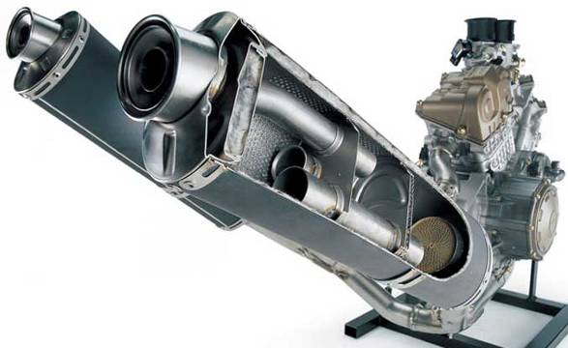
Some pics of the process. Open the cap end LAST. Open the other end (Inlet) first. BUT I recommend NOT TO TAP the end cap out with a screwdriver like I show in these pictures. You are better off inserting some wood or something into the inside of the muffler once the other end is removed and hitting it out fron the inside.
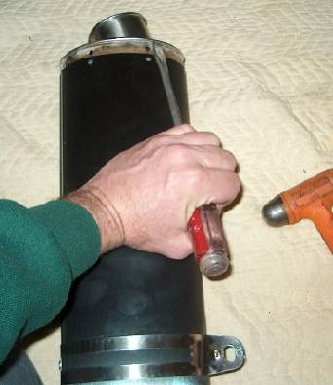

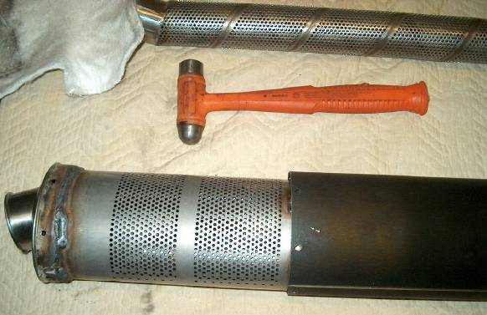

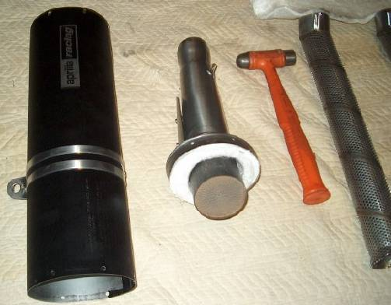

pic 6 BELOW, is of busting out the platinum cats. But try using a drill. We found the drill MUCH easier. We used a concrete drill.
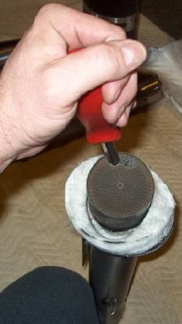

Pic 7 the damn thing finally removed.
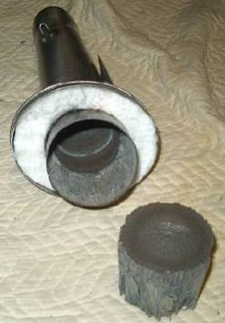

pic 8 wrapping the new baffle with the stock packing first then we wrapped new packing above the old stock packing too. No pic of that here.
But make sure you do add the extra packing. Also, use a spiral core if you can as it sounds a little bit deeper, but there is not much in it so don’t stress if you cant find one.
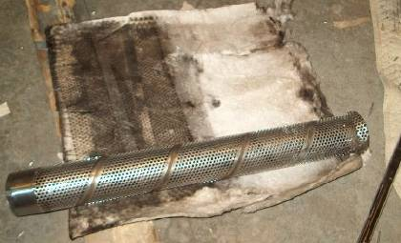

here are the two types of baffles the straight through which is louder and the spiral baffle. they make the same power! the spiral sounds better, deeper tone,

The centre tube is a standard core from M4, 2 1/8" round by 18" long, fully perforated (replacing the internals of the absolutely gorgeous stock silencers with conventional perforated core stainless baffles of about 2.5 inch internal diameter) (I used a straight through pipe of 65mm.) Don’t worry about finding one with the down turned bit at the end. Straight is fine.

Here’s the product on the bike. Theses are off my bike and don’t have the shims like the Milleman kit.
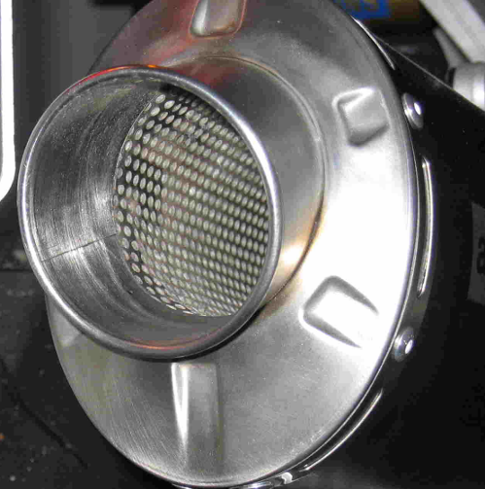
another view
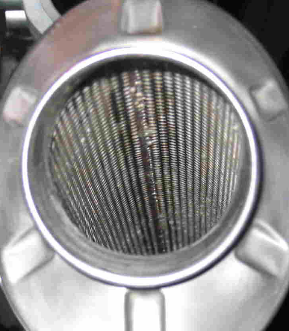

U use a die grinder to cut off the end cap off the inner muffler! Then you toss the inner muffler. You cut it at the weld! Towards the end cap
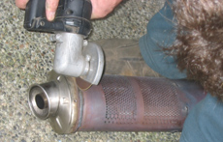

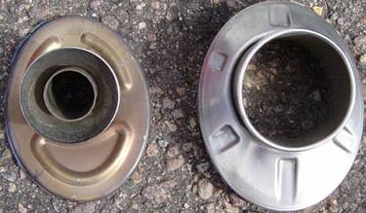
End cap next to restrictor that had to be cut out.
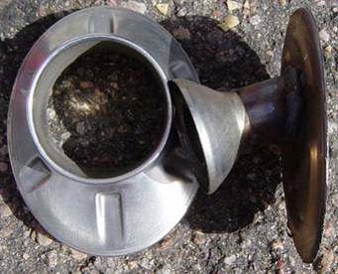
The CAT before I tore the hell out of it.
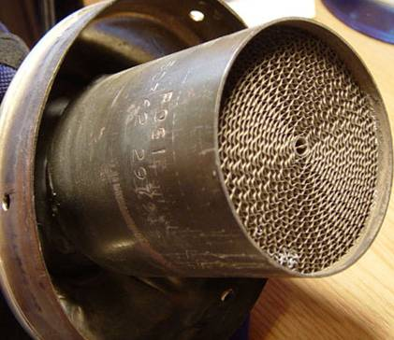
Next you can see how big the chunk of platinum they use for the CAT is. Note in prior pic how small the holes in the Cat Converter are that the exhaust gas is trying to push thru. Had to remove by prying down all the sides of it to peal it free from the wall. Then took a big ass hammer and hit it with an even bigger ass hammer from the other way to drive it out this side.
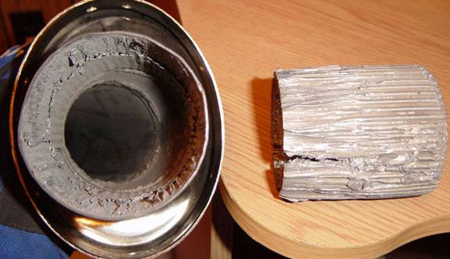
Now all the bits ready to go back together, No jokes about my jungle blanky either, its kicks ass and you know it.
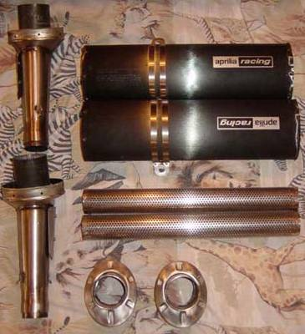
Taking shape, riveting the lower half back onto the can.
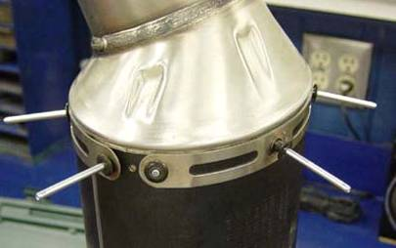
Core used by the guy that took some of these pictures was from Yamaha, used for the YZ450 I think, he said it fit perfectly, but I would check the diameter. I put a little more packing around this as well, but didn’t picture it. Had to make sure to use enough though, did some pre runs, with a lot less and held it all together with my hands, wow way too loud. Very nice sound now.
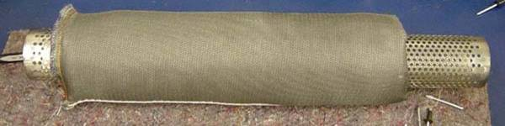
My short Cans
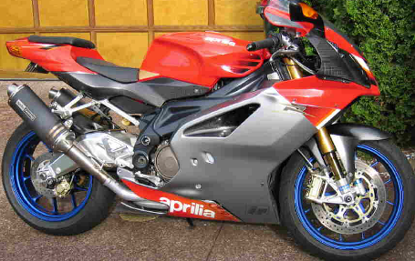
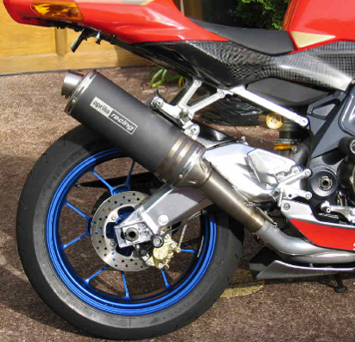
Short can hangers
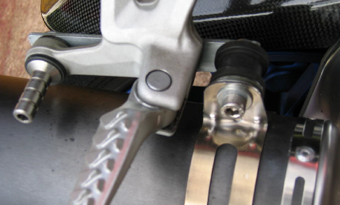
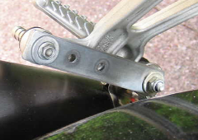

Here is some Questions and Answers regarding the core job and the pic below
1- Cat converter: What is the outer diameter (where the core is inserted). (65-70mm according to your paper?) 67mm I believe from memory.

2- Core, length. ( I read your comments in regards to material and thickness) Note: I will not shorten the cans. About 450mm. I think I got them at 450 and then used a hack saw to nip a little off the end to get them exactly right. It only takes 5 min to trim off with a hand saw.

3- Diameter of core (where it is inserted to the cat hole) I had my cores made at 65mm outside dia. However in order to get them to fir into the INSIDE of the Cat hole I had to make some cuts about 3-5 cm long, along the length at the end of the core. I have drawn these in red on your diagram. I put about 3-4 of these in. What they did is allowed the end of the core to close up a little as I pushed it into the tapered end of the Cat hole. Basically, the cat hole tapers down, so this enables the core to snugly wedge in place.

4- End of core where does it get inserted? This end was spot welded to the end cap on the inside. I think it is TIG welded. BUT>>> that reminds me… You have 2 main choices for how you treat the exit hole.

1. Cut the full inside section of the end cap out. This leaves you with a 65mm outlet (appox 63-65). This is the easiest way of doing it but may not give the max power. But still a very good result. You can then attach a 65mm core direct to the end cap with a few spot welds

2 or… you can use a tapered core that ends at 55mm dia exit hole. Then have a short ‘tapered cone’ about 10-20mm longattached to the exit end of the core (The short cone in my pic would be 65mm exit end and 55mm entry end. Exit end attaches to the end cap and entry end (55mm) attaches to the core) this tapered little end bit (as per my drawing) is welded to the 55mm exit end of the core, it enables the core to taper out to the 65mm exit. Confused??? I have drawn a very dodgy pic of what I mean. (It can be solid with no perforations). You will not see this short tapered bit once the pipe is used and has soot in the end. (If you get a custom core made they may be able to easily just taper the very end bit of the core without welding my short tapered end bit.)

3. Use a 55mm core. Straight through. It will slot into the CAT end ok, but it slides farther into the cat’s hole… so the core needs to be a little longer. The 55 core would then attach to the end cap in 1 of 2 ways. Either use the extra ‘tapered’ bit I drew and weld it to the core (as per the pic). Or 2. don’t fully cut the end out of the end caps….

In other words. Instead of cutting all of the inside out of the end caps, just cut a 55mm dia hole in the end of them. Remember, the end caps currently have a very small exit hole in stock trim) But this could be fiddly??? Not sure .

5- What is the diameter of this end? Well, that depends on what you do with all the crap I wrote above (grin) . It could be 65mm. Which makes for a very easy conversion. Or it could be 55mm, which makes for slightly more midrange power, but a little more effort to get it to attach to the end cap.

