Here's how to make your own airbox kit and hold the filter down!

http://www.apriliaforum.com/forums/showthread.php?s=&postid=361854#post361854
This link has a lot of additional info for you too. So check it out as well. There are numerous pictures in this document so I hop they show up for you.
Here is the easy way to make your own airbox Kit. It takes about 1 1/2 hours.
You will need... (there are pictures attached to explain these)
1. some silicon glue or sealant. I simply used a silicon gasket sealant.
2. Some sealing rubber from around the door or the boot of a car.
3. A thin piece of rubber hose (or similar) to slip inside the cavity/hole that runs through the middle of the door sealing rubber. This helps give extra support. The rubber I purchased for a few dollars was very soft, so needed the support. However I have since then similar rubber that does not need it.
In a nutshell. All you do is remove the top of your airbox and put it on a shelf (you'll probably never use it again). Also remove the foam that is stuck to the underside of yopur tank. It can be a prick to get it all off. But remove it with the airbox lid still in place as you dont want foam getting into the airbox.
Then push the car door rubber down over the top of the lip of the airbox.
Around the front two corners of the airbox I needed to trim away part of the rubber so that it was able to turn the tight corner. I also pushed the rubber in this area slightly further outward because this was the only part that I found did not Seal completely against the underside of the tank. In other words... in the front corners I made sure the rubber sat about 10 millimetres further out from the edge of the side lip of the airbox. I sealed it in place using some silicon gasket sealant.
To hold down the filter and keep it in place I use a very simple system with a reusable plastic Tie. In my picture you'll see only one tie in the middle. But this let the ends of the filter lift when air rushes in. So I reccommend 2 ties. one about 20% of the way along the front and one at 80% of the way along.
The other simple alternitive to holding down the filter lid is a strip or 2 of Velcro. Just make sure it cant come loose and get sucked down the trumpets.
For each tie I made two small slots in the side of the airbox housing and slipped the tie into the bottom slot (Slot A)--(which goes into the unfiltered area) then pushed it out the top slot (Slot B)--(which brings it back out into the filtered airbox area). Refer to the pictures for this.
I then made one slot in the lid (Slot C) that holds down the filter and slipped the plastic tie up through that slot and back down onto itself, where I clicked it closed.
This holds the filter in place, is simple, and wont come loose to go down your throttle bodies.
I recommend you put a little bit of silicon sealant around the two 'tie' slots in the side of the housing. This will ensure they remain sealed. This is the only area that mine let in any dust. And you can see a little bit of dust in the photo around this area. I have subsequently sealed it and now no dust comes in.
Once you have the rubber pressed down over the top edge of the airbox (but not sealed in place yet) I recommend you take some silicon grease (or similar) and smear it around the outside edge of the rubber. Then carefully close the tank down over the top of it, then reopen the tank and check around the inside edge of the underside of the tank to see that the silicon grease has transferred to the tank all the away around.
Anywhere it hasnt transferred is somewhere that the rubber is not contacting and sealing against the underside of the tank. I just built up/pushed out the rubber at this point to ensure contact is made. I found mine contacted all the way round accept the front to corners of the airbox. These needed pushing out by about 10 millimetres.
Once you think you have it correct. Then pull the rubber off and put the silicon gasket sealant (or similar) all around the top lip of the airbox. Also squirt it into the seam around the edge of the rubber. Now press the rubber back down into place across the top lip of the airbox and push it down firmly. Wipe off any extra sealant. Run a bead of sealant around the outside bottom edge to ensure that is sealed there as well.
Leave the tank up and leave it all to dry overnight. In the morning put some more silicon grease around the edge of the rubber to help the tank slip over it, put the tank down. Pull it up and check one more time that it is sealing all the way round. And if it is, close it and go for a ride. You're done.

My EVO airbox additions
I know there are a million posts here on this stuff. This is what I did to make a good product/concept work better. First of all, the inside of the stock tank needs to be smoothed out with some sandpaper and/or chemicals to be able to make a good seal. I don't care what you use to make a seal, if the inside of the tank is rough (left alone as stock) it will vibrate away at the seal and it will fail not to mention all the bits your engine can and will suck in. Secondly, you need to go to Home Depot or similar and get some auto/marine weather stripping like this that is resistant to fuels/oils/petroleums. Don't use the household window-type of stuff as the fuels will ruin it. There is probably enough in the box I bought to update 2 kits with. It fits perfectly right on the EVO rubber seal/lip. Just cut the length to fit - don't cut it until you've wrapped all the way around while adhering the strip then cut where it's obviously going to end. You will need to put some airbox grease on the rubber seal when you are done to ensure a good seal against the tank. Finally, I used some stretchable O-rings (auto parts store should have these - must be stretchable kind), a couple plastic clamps and a couple wide screws with a pronounced screw head. Drill a small pilot hole where the screws will thread in. Don't screw into your filter (dummy), take it out first. Screw in the screws enough to where they will help to secure the filter in place snug without screwing into the filter. Put the filter in place, clamp the o-rings in place, stretch the o-rings over to the screw heads. See pics, pretty self-explanatory in the pics.
No matter what airbox you do, you MUST smooth out the inside of the tank. Be sure to cover your throttle bodies while they are exposed to debris. I think you can actually use paint stripper/remover to get to bare tank. The plastic of the tank should be the smoothest surface, I don't know why I didn't think of it before. I would completely remove the tank to do that though - mind you the '04 doesn't have quick release fuel lines like previous models. Oh yeah, my local auto parts store had the plastic clamps. They are screwed into the existing stock air filter lid screw holes - using the stock screws. It might be a good idea to cut about 1/8" or so of small rubber vacuum line and put over the screws where the O ring goes over. That should prevent the screw threads chaffing/cutting the o rings and causing them to break off inside the airbox.
At a minumum I'd put some electrical tape around it.
This is how the inside of my tank looks after a few race weekends of use. What you are seeing is the airbox grease making a good seal everywhere on the tank. You actually hear and feel the tank "pop" open from the seal when you open it.
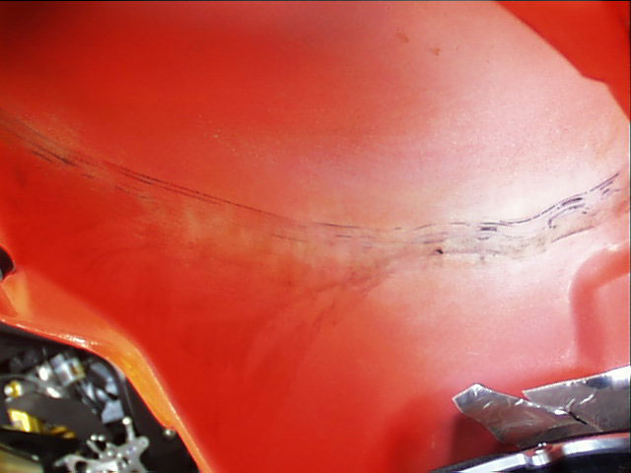

You will literally feel the difference through your knees when riding the bike under hard acceleration. There is such a vacuum effect from the great seal it tends to make the tank vibrate a little more. It should be very snug when you push the tank down. I have to push real hard to get the front pins in place.
K&N actually make air filter grease. That's what I used. I think it's mainly used for offroad since the foam filters on some older dirt bikes are totally exposed and you would want to make a real good seal where that foam filter was attached. All that being said, I see no reason why you can't use that blue, waterproof stuff that BelRay makes. I use that for lots of stuff requiring a real grease.
i would sand the underside of the tank with the airbox cover in place. vacuum up the remains and then remove the top of the box for installation.

Note plastic screw-type clamps holding o-rings.
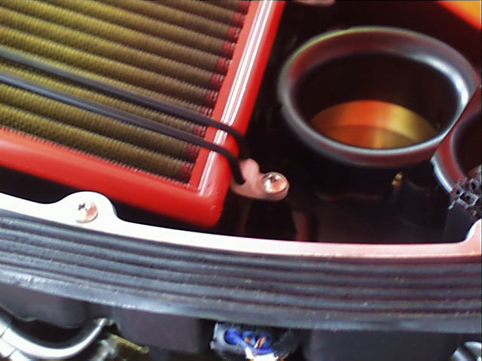

Note front screws. Be sure to use a decent size screw for several reasons. O-rings need to hold secure and you don't want the screws to rip out either! The last thing you need is to suck them
into the tank. Mine have not moved at all after 3 race weekends.
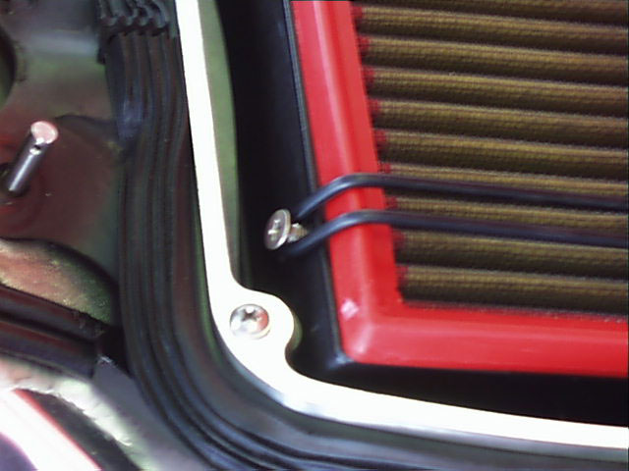
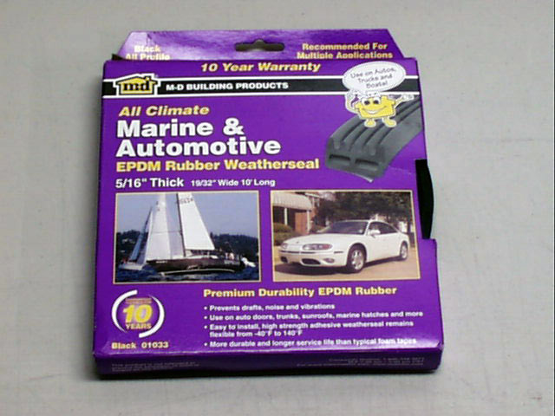

Another option…The seal is provided by automotive trunk seal. It's called "Pinch weld and seal".
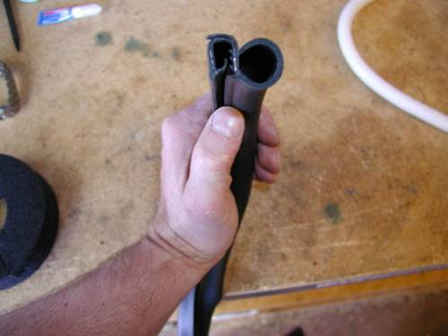
I put this closed cell polyethelene foam inside the pinch weld and seal to add strength to the sealing tube. Probably not necessary as the seal is so good now you have to really push the tank down to get it to close.
Lowrance has attached this image:
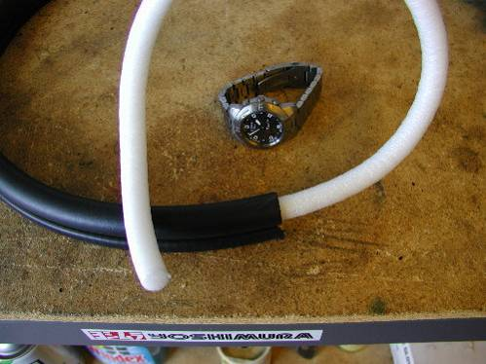
Apply a liberal amount of silicon grease to allow the tank to close smoothly and promote a better seal.
Lowrance has attached this image:
